**Title:**

Soil and Water Analysis System for Sustainable Farming

**Introduction:**

The aim of this project is to assist farmers in optimizing soil and water conditions for crop cultivation. It evaluates critical parameters such as soil salinity, nutrient levels, and water pH and provides actionable recommendations to address deficiencies or excesses. This tool is especially relevant for regions facing agricultural challenges due to waterlogging and soil salinity, empowering farmers with data-driven insights to enhance productivity.

**Background (Research & Project Selection):**

The project is inspired by the challenges faced by agricultural communities, particularly in regions like Sindh, Punjab, and Balochistan. High soil salinity and imbalanced nutrient levels have led to reduced crop yields. Research indicates that precise interventions like gypsum application, urea supplementation, and pH correction can mitigate these issues. This project seeks to automate the analysis process, bridging the gap between scientific recommendations and field implementation.

**Project Specification:**

**Programming Language:** C

**Core Features:**

* Input soil and water parameters (e.g., salinity, nitrogen levels, pH).
* Validate crop suitability for region and season.
* Provide recommendations for fertilizers and materials.
* Estimate required quantities based on land area.
* Generate a detailed report in a text file.

**Target Users:** Farmers, agronomists, and agricultural researchers.

**Scope:** Cover crops like Wheat, Cotton, Rice, and Sugarcane with predefined optimal ranges.

**Problem Analysis:**

The project addresses the following problems:

* **High Soil Salinity:** Reduces plant growth and yield.
* **Nutrient Deficiencies:** Impacts crop quality and productivity.
* **Water Table Issues:** Suboptimal levels hinder root development.
* **Manual Analysis Challenges:** Time-consuming and error-prone methods make it difficult for farmers to determine soil health accurately.

**Solution Design (Project Details, Functionality, and Features):**

**Project Details**

**The program uses a structured approach:**

Inputs soil and water parameters.

Validates crop selection based on region and season.

Compares input values with predefined optimal ranges for the selected crop.

Provides actionable recommendations and estimates required materials.

**Functionality and Features**

**Region and Season Validation:** Ensures crop compatibility with environmental conditions.

**Soil and Water Analysis:** Evaluates salinity, nutrients, and pH levels.

**Recommendation Engine:** Suggests corrective measures for identified issues.

**Material Estimation:** Calculates gypsum, urea, lime, and other materials required per acre.

**Report Generation:** Saves a detailed analysis report to a file.

**Implementation & Testing:**

**Implementation:**

The program is implemented in C and leverages:

**Structures** for crop data storage.

**Arrays** to hold soil and water parameters.

**File Handling** to save analysis reports.

**Pointers** for Efficient Memory Handling

**Functions** for Modularity

**Control Structures** for decision-making and analysis.

**Testing:**

Testing was performed with sample inputs representing real-world conditions:

High salinity with low nitrogen.

Low potassium with balanced pH.

Valid and invalid crop-region combinations.

**Project Breakdown Structure (Workload Distribution with Timeline):**

|  |  |
| --- | --- |
| **Task** | **Responsible** |
| Project Idea | Umer |
| Research | Umer |
| Structuring | Neeraj |
| Functionality | Neeraj, Sameer |
| Testing and Debugging | Sameer |
| Documentation | Umer |

**Results (Output Screenshots):**

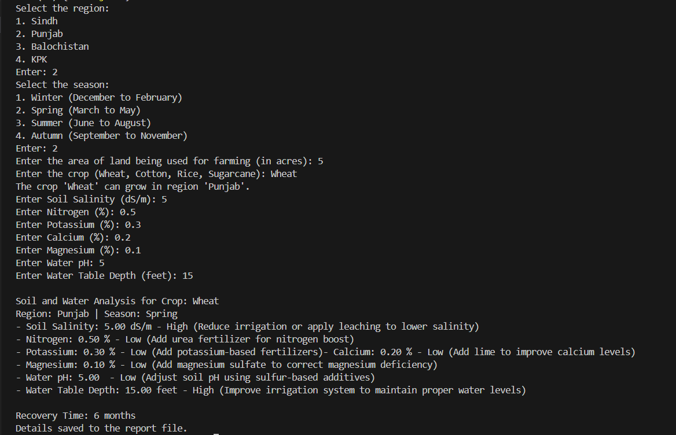

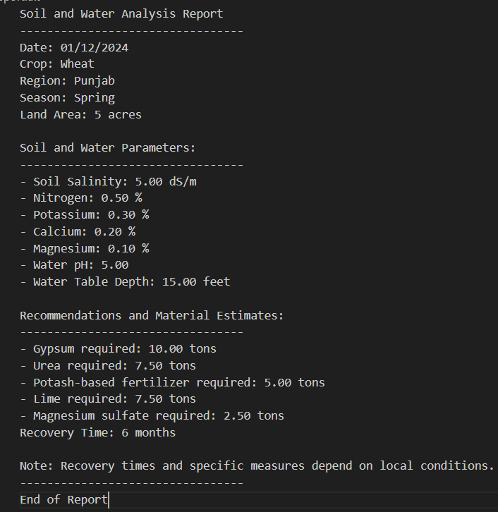

**Conclusion:**

The project successfully provides a comprehensive tool for soil and water analysis, tailored for the agricultural sector. By automating parameter evaluation and material estimation, the program reduces the guesswork and effort required by farmers to maintain soil health. Testing indicates the program's reliability for different input scenarios, making it a valuable resource for improving crop yields.

**Future enhancements could include:**

* Integration with IoT sensors for real-time data collection.
* Support for more crops and regions.